Toy Model #3

The equations that define the simple Toy Model are described in Equations 1 and 2.

|  |  |  |
| --- | --- | --- |
|  | $$\frac{dΦ}{dt} =-βV =L_{Φ}$$ $$\frac{dV}{dt} =βΦ =L_{V}$$ | (1)  (2) |

Then with diffusion added Equations 1 and 2 become 3 and 4 as follows;

|  |  |  |
| --- | --- | --- |
|  | $$\frac{dΦ}{dt} =D\frac{d^{2}Φ}{{dx}^{2}} + L_{Φ}$$ $$\frac{dV}{dt} =D\frac{d^{2}V}{{dx}^{2}} + L_{V}$$ | (3)  (4) |

# Results 1a

Initial simulation results with and without diffusion are shown in Figure 1 and 2 respectively with a beta described by Figure 3.

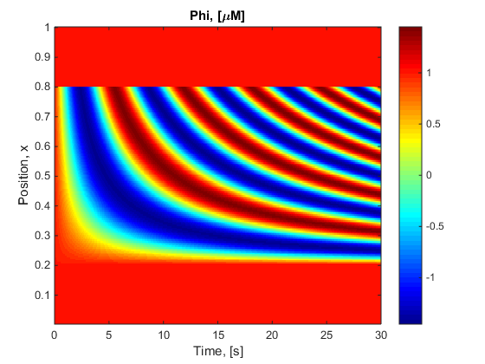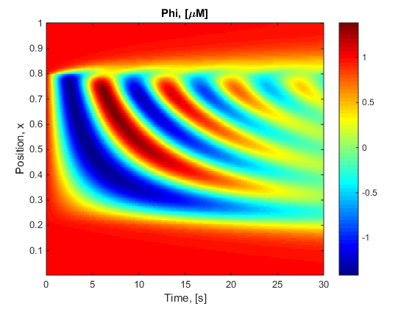

Figure 1 and 2: Phi over time and space for Zero diffusion (Eq. 1&2) and D=100e-6 (Eq. 3 & 4) with Beta described by Figure 3.

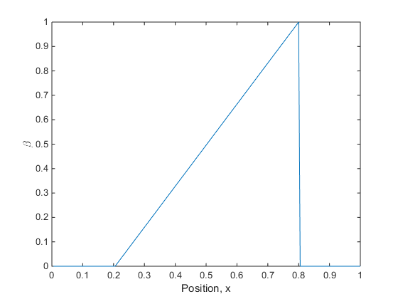

Figure 3: Initial Beta choice

# Results 1b

The results in section 1a were recomputed over 100s in time with the same Beta described by Figure 3.

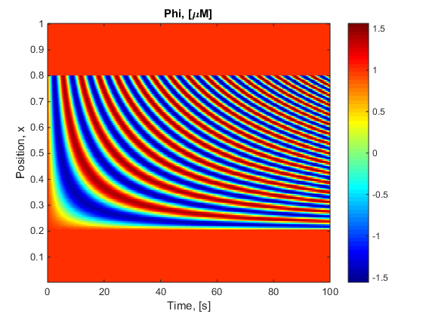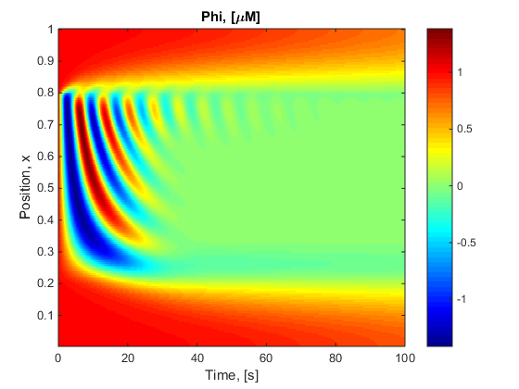

Figure 4 and 5: Phi over time and space for Zero diffusion (Eq. 1&2) and D=100e-6 (Eq. 3 & 4) with Beta described by Figure 6.

# Results 2

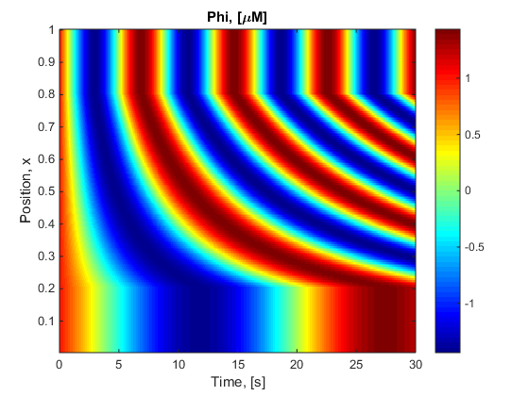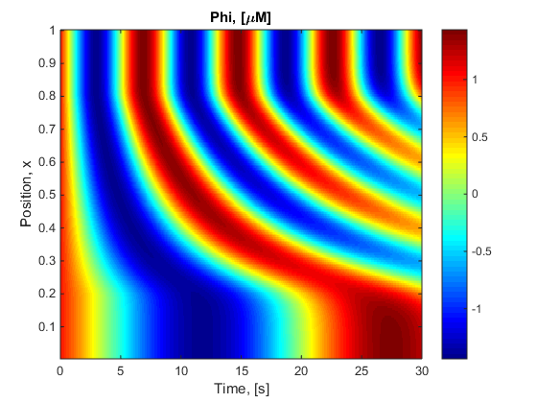

Figure 6 and 7: Phi over time and space for Zero diffusion (Eq. 1&2) and D=100e-6 (Eq. 3 & 4) with Beta described by Figure 6.

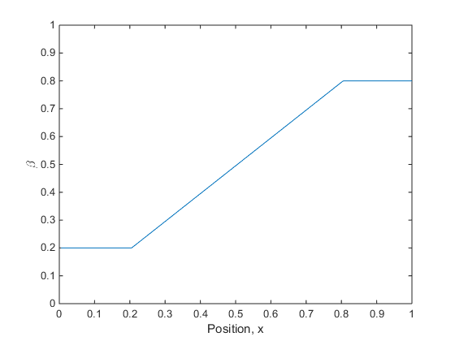

Figure 7: Secondary Beta choice

# Results 3

The simulation to produce the results in Section 1 have been rerun with varying Diffusion coefficients, D.

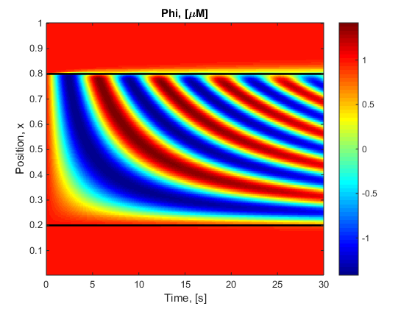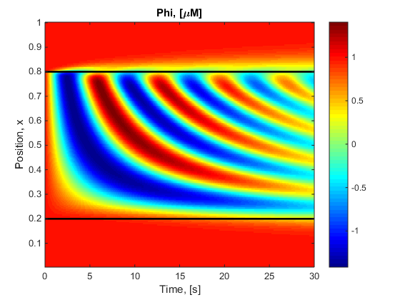

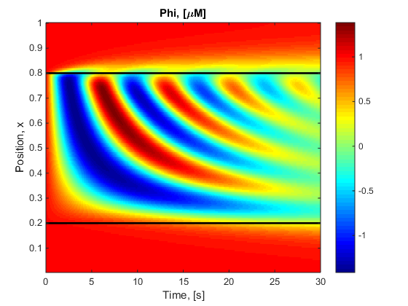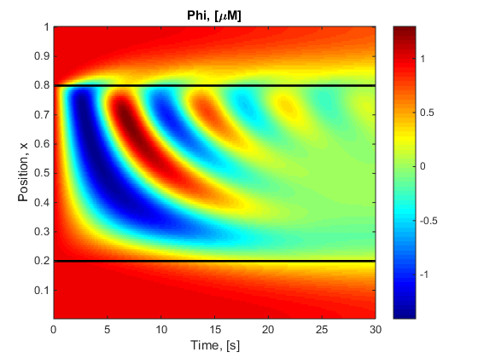

Figure 8 to 11: Phi over time and space D={10e-6 (TL) , 50e-6 (TR) , 100e-6 (BL) , 300e-6 (BR) } (Eq. 3 & 4) with Beta described by Figure 3.

# Results 4

For this results a combination of Equation 3 and 2 have been used; Diffusion only Phi.

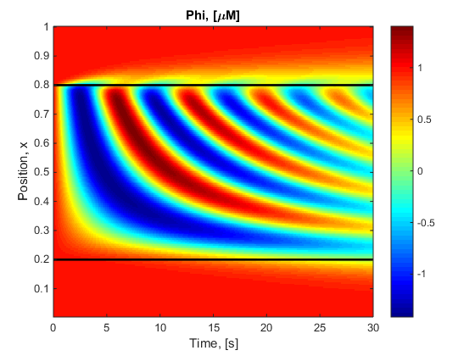

Figure 12 and 13: Figure 2 repeated for side by side view (Eq. 3 & 4) and Phi over time and space D=100e-6 (Eq. 3 & 2) with Beta described by Figure 3.

# Discussion

* More diffusion produces qualitatively similar behaviour, but it happens sooner
* Similar results with diffusion on phi vs both (but slower when diffusion on just phi)
* Picture looks a bit different depending on which beta is used.
* No nonlinear behaviour